Regalia Information for Graduation 2020

Location: Zoom. Link to virtual graduation will be provided soon
Graduation Date: August 7, 2020 – Friday
Ceremony Start: 5pm
Form to Participate in Virtual Graduation: https://forms.office.com/Pages/ResponsePage.aspx?id=V86IrTnQd0K3uMQU89Wa7z5Cg7bWT_1CjgOtki2OfmZUQUQ5QlBaUlBIMFRVUTdYRko5OU5DN01EWS4u

STEPS TO ORDER REGALIA

- MUST READ: Jostens Flyer
- BEFORE ORDERING ONLINE SEE REGALIA GUIDES BELOW
Doctoral Regalia Guide
Masters Regalia Guide
Certificate/Associate Program
- LINK TO ORDER ONLINE: www.jostens.com

ATTENTION PACIFIC COLLEGE OF HEALTH AND SCIENCE GRADUATES – SPRING 2020 COMMENCEMENTS IS FRIDAY AUGUST 7TH, 2020. TIME TO ORDER YOUR CAP & GOWN!
Graduates – ONLINE ORDERING ENDS BASED ON REGALIA ITEM ORDERED – SEE DATES BELOW
- Go to www.jostens.com or call 800-854-7464 Jostens Customer Care
- Go to line “Get started now: and enter “Pacific College of Health and Science”
- Your school will appear on the list below, please click on your school’s name
- Your School’s homepage will open showing cap and gown, announcements and frames
- Please click on the picture of the graduation cap and gown and select “Student Caps and Gowns or Student Doctor Regalia.”
- Associate outfits include cap, gown, and tassel.
- Master students can choose either a full outfit or just a master hood.
- Doctoral students can choose a full outfit, just a hood, just a gown, or just a one way tam.
- Individual gown, cap or tassel online ordering ends August 7, 2020.
- Master and Doctor Hoods and Tam online ordering ends on April 23, 2020?
- Select your height and enter your weight.
- Pleaser review your summary page and when ready, add to the cart.
- You can continue shopping for announcements, diploma frames or continue to checkout by entering your first and last name, then click on checkout.
- On the following page – Continue as a guest.
- Complete the billing information, including email and phone number should Jostens needs to reach you. This is the address that Jostens will ship your regalia. Click on continue.
- On the finalize order page, choose standard rate or express ($20 additional fee). Choose your payment option and review your order summary to make sure it is correct. When complete, submit your order. Your order is shipped to the address you provide by UPS Ground.
- You will receive an email confirmation within 24 hours that your order has been received by order processing.
- Please check your order when you receive it. Problems – please call 800-854-7464
- After the website closes, if you still need to order, please call Jostens Customer Care at 800-854-7464 to place your order. Late orders include an express processing fee of $20 in addition to regular charges, may arrive up to and including the day of graduation, hood colors may be substitutes to meet your graduation date, and are non-refundable or guaranteed.
Jostens Customer Care 800-854-7464
Monday through Friday 8am – 5pm Central Time

DOCTORAL REGALIA GUIDE
2020
Click here to return to Main Page

GOWN Elements Doctor. Gown: Ash (Black) Trim: Velvet w/ Hood Button
CAP Fine Quality Custom. Tam 8-Sided Deluxe Black
HOOD Elements Doctor. Band: Gold. Lining: Royal Blue Chevron: White. w/Cord Button TASSEL Regular. Banded. Gold. Year date: 2020 Gold.
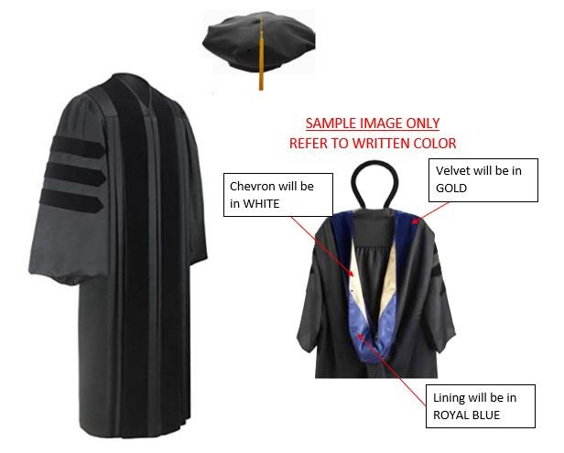

MASTERS REGALIA GUIDE
2020
Click here to return to Main Page

GOWN: Bdg. Master. Black. w / Hood Button.
CAP: Bdg. Hard. Black
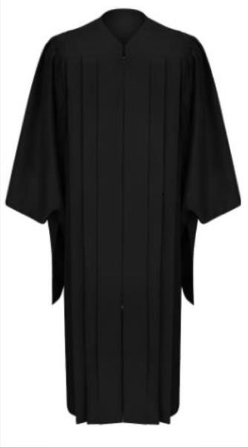
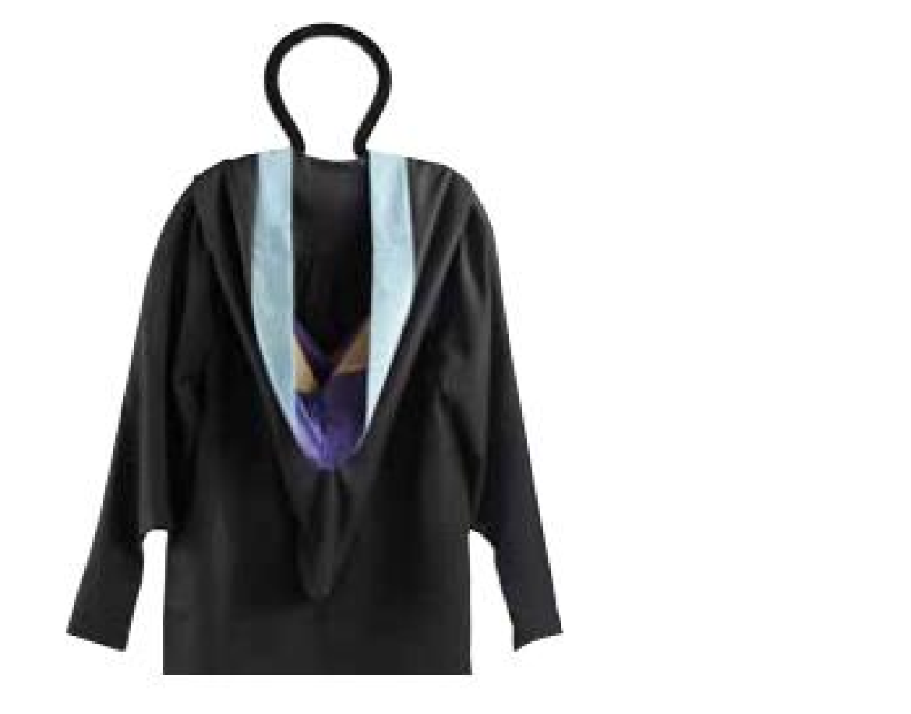
HOOD: Bdg. Master. Band: Royal Blue. Lining: Royal Blue. Chevron: White. w/Cord Button TASSEL: Regular. Banded. Royal Blue. Year date: 2020 Gold.

Velvet will be

In ROYAL
BLUE

SAMPLE
IMAGE ONLY

REFER TO WRITTEN COLOR

Chevron will
be in WHITE

Lining will be in

ROYAL

BLUE

CERTIFICATE/ASSOCIATE REGALIA GUIDE
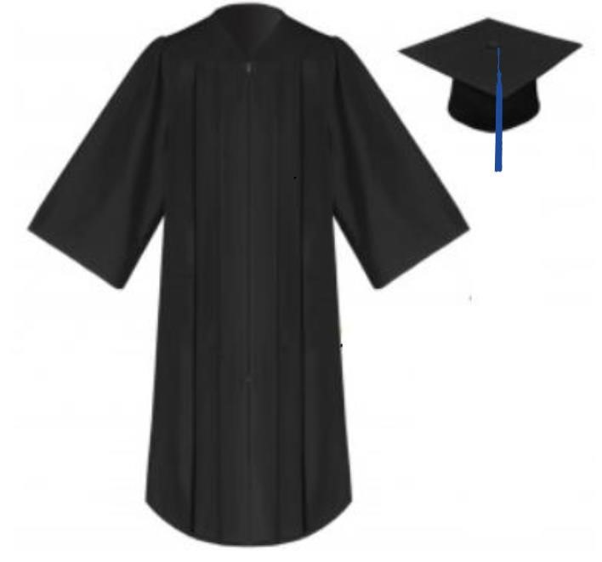
2020
Click here to return to Main Page
GOWN Bdg. Black.
CAP Bdg. Hard. Black.
TASSEL Regular. Banded. Royal Blue. Year date: 2020. Gold

