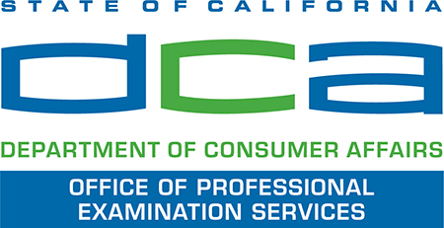

COVID-19 Safety Precautions
for In-Person Examination Development Workshops
May – June 2020
- Workshop participants must wear masks or other protective face coverings. All masks and face coverings will be subject to a security inspection at check-in.
- OPES will stagger check-in to promote physical distancing practices.
- At check-in, SMEs will be required to confirm that they are not feeling sick or having symptoms of fever or respiratory illness.
- OPES will practice physical distancing during workshops. SMEs will be seated no less than 6 feet apart.
- Meeting rooms will be wiped down frequently with disinfectant wipes, and hand sanitizer will be available. SMEs will be allowed to bring their own hand sanitizer and disinfecting wipes into workshop rooms.
- Pens and pencils will be provided; however, SMEs will be allowed to bring their own nonmechanical pencils.
- Noncontact methods of greeting will be practiced; handshakes will be avoided.
- If an SME shows signs of illness during the workshop, the SME will be asked to leave.

NOTE: The above safety precautions are in accordance with guidance from the California Department of Public Health (CDPH), the Centers for Disease Control and Prevention (CDC), and the Division of Occupational Safety and Health (Cal/OSHA). For more information, see the guidelines below:

1. CDPH, Guidance on Gatherings, dated March 16, 2020
2. CDPH, Guidance on Face Coverings, dated April 1, 2020
3. CDC, Guidance for Businesses and Employers to Plan and Respond to COVID-19, dated April 9, 2020
4. CDC, Guidance on Keeping the Workplace Safe, undated
5. Cal/OSHA, Guidelines for General Industry on 2019 Novel Coronavirus Disease (COVID-19)

